Name: Jay Rajesh Umap

Roll No.: 2205010

Enrollment No.: MITU20BTIT0029

Class: TY IT

Div.: CORE

1.Create a view by name book_view which contain book name, author name and price and display the same.

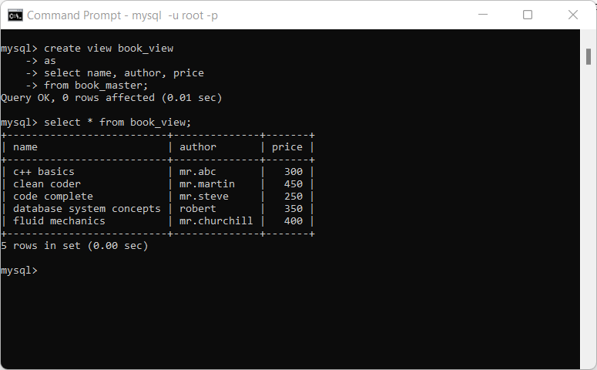

2. Create a view by name unreturned_books, which contain book-id, book-name and display the same.

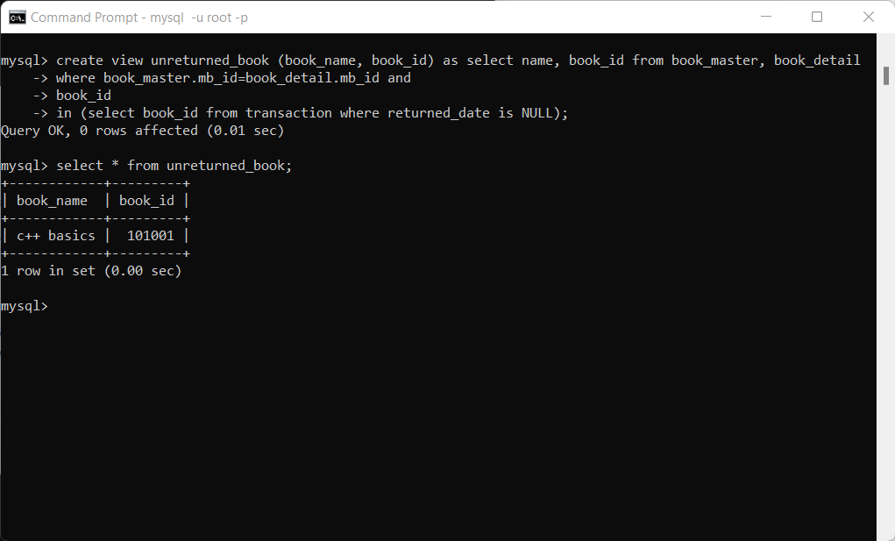

3. Create a view student_view having all fields of students and add a record through student_view.

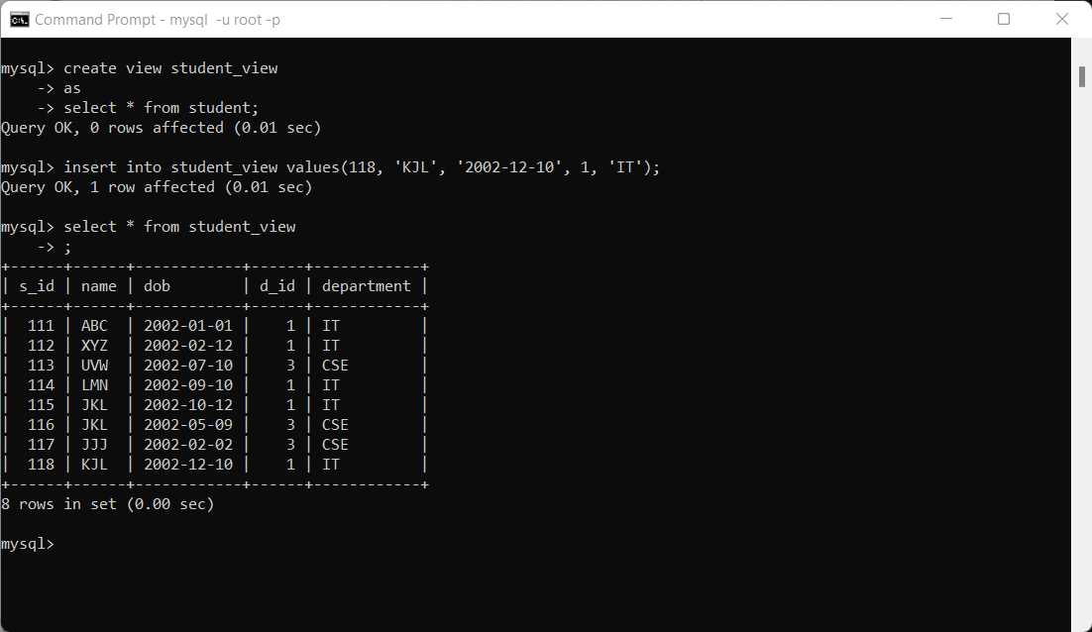

4. Show the book names of the books which are borrowed so far. use join

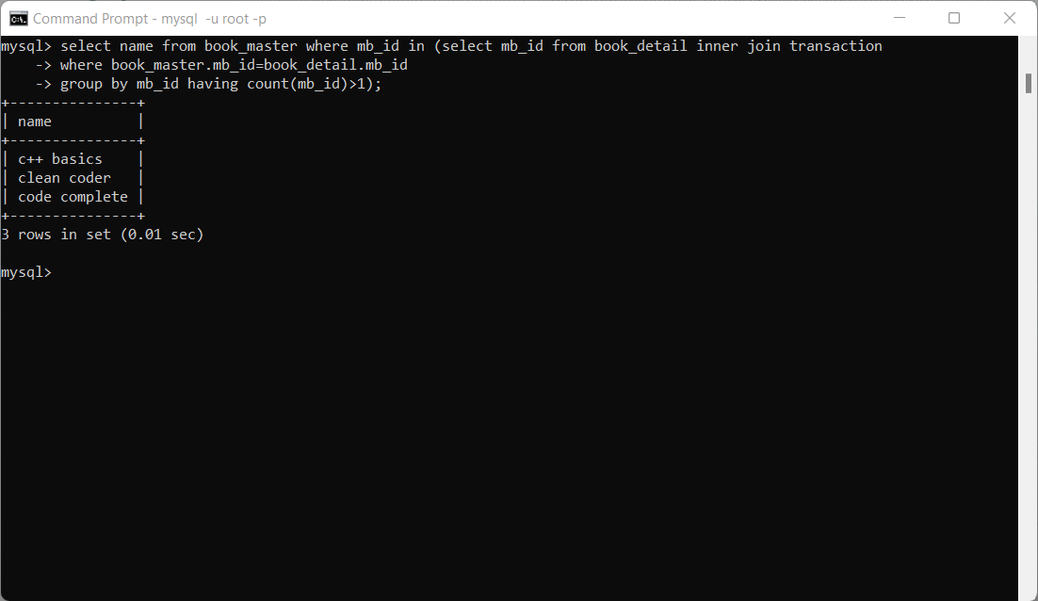

5. Display all the books master ids along with the issued date and student id to which book was issued use join.

6. Display book_name and student name who has borrowed that book.

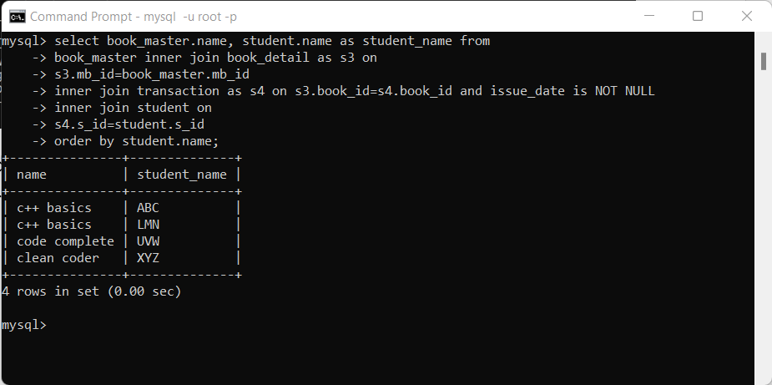

7. Add a record of a student with repeated roll.no. what is your observation.

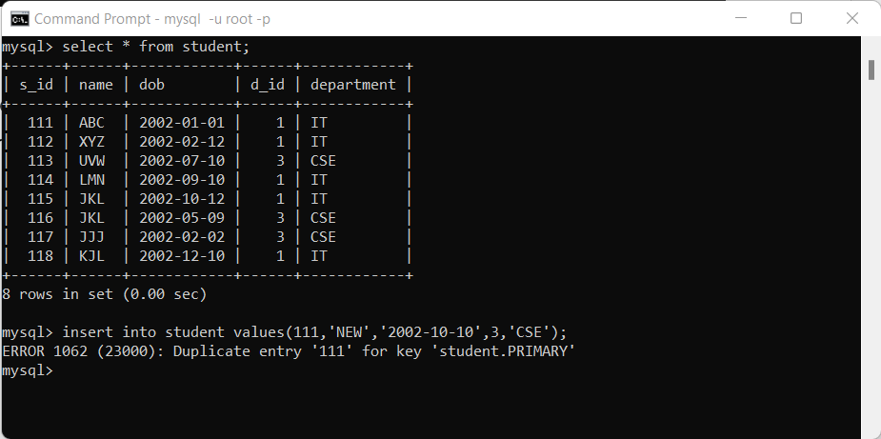

8.

5. Display all the book ids along with issued_date and student name to whom book was issued. Use join.